|  |
| --- |
|  |
| USA Flight Performance |



Contents

1. Business Description 3

1.1. Business background 3

1.2. Problems because of poor data management 3

1.3. Benefits from implementing a Data Warehouse 3

2. Dimensions of a Business 3

3. Logical Scheme 3

4. Data Flow 3

5. Fact Table Partitioning Strategy 3

6. Strategy of Parallel Load 3

7. Report Layouts 3

# Business Description

## Business background

* + **Business background**

DWH will provide research department of the all airports and companies schedule with flight performance information (departures, arrivals, etc.).

* + **Problems because of poor data management**

Today it’s hard to know/analyze data about flight performance.

* + **Benefits from implementing a Data Warehouse**

As a result the data will have performance statistics that can be analyzed to improve companies and airports schedule and gain more passengers by static time flights.

# Dimensions of a Business

1. Airlines Dimension
2. Pilot Dimension
3. Plane Dimension
4. Location Dimension
5. Flight performance as fact table

# 3NF model

# 

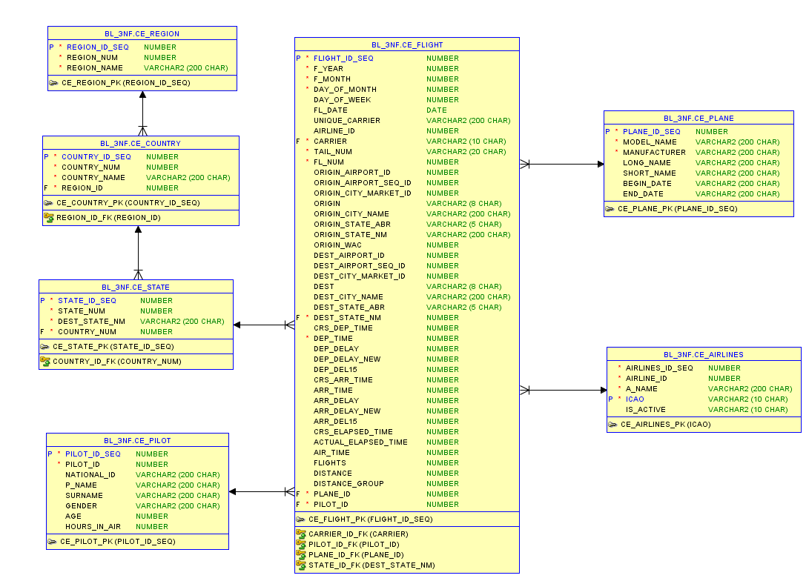

Figure 3NF schema

# Logical Scheme

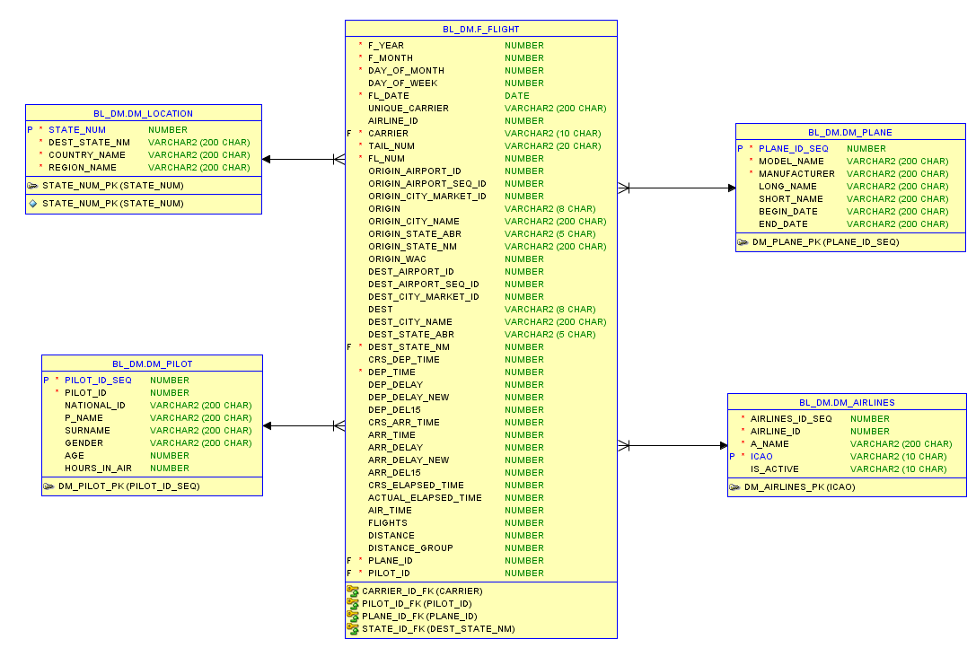

Figure Dimension schema

# Data Flow

To load data some settings must be done.

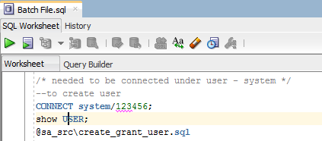

Creating directories and give grants:

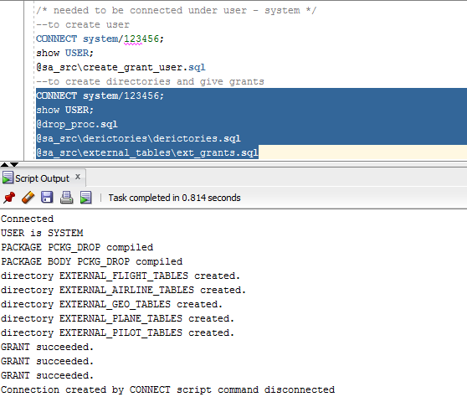

sa_src layer load:

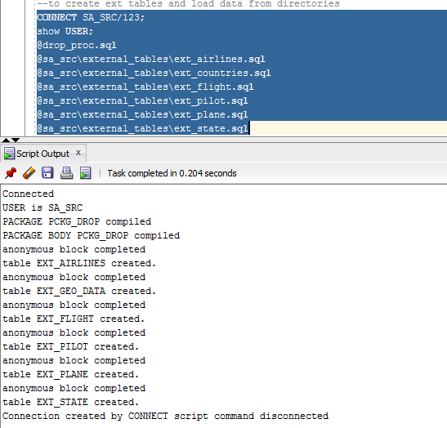

Bl_cl layer – loading data to wrk tables:

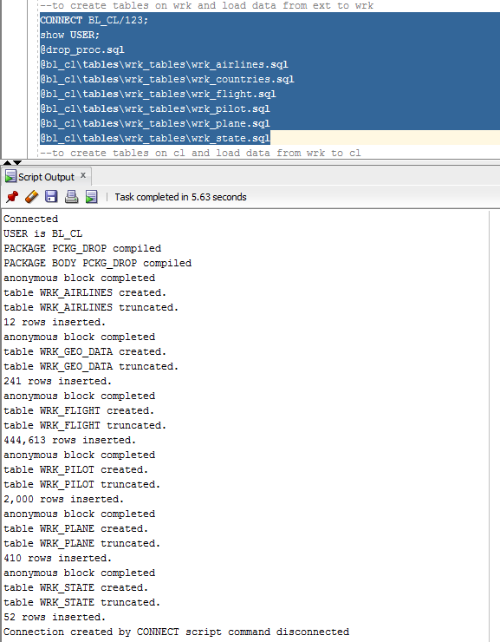

To load everything to cleaning layer (cl_tables):

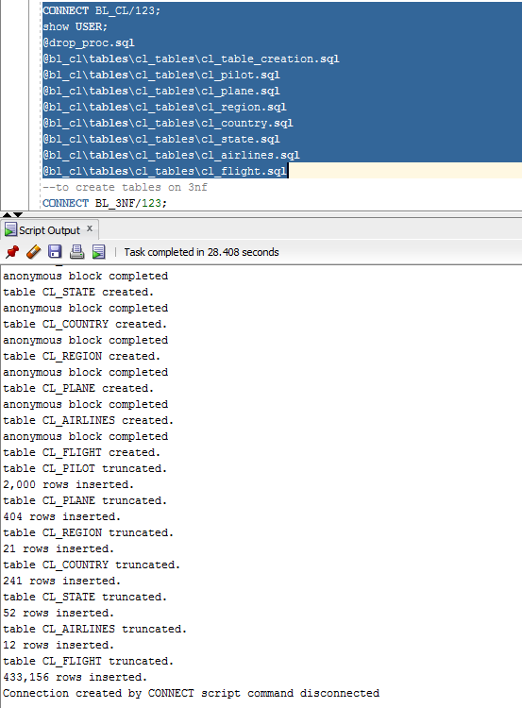

To create 3nf tables:

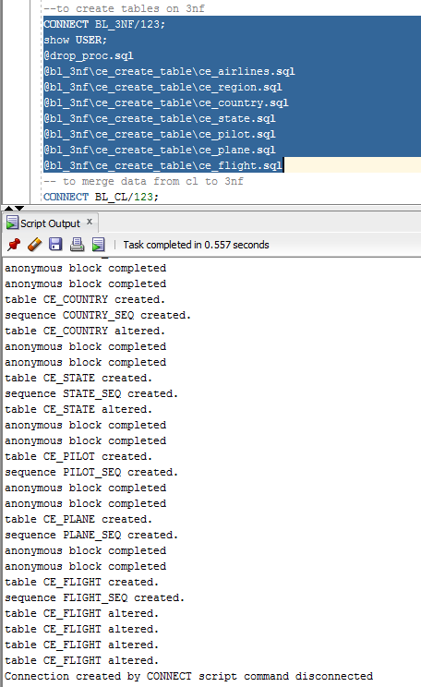

To merge data from cl tables to 3 nf tables:

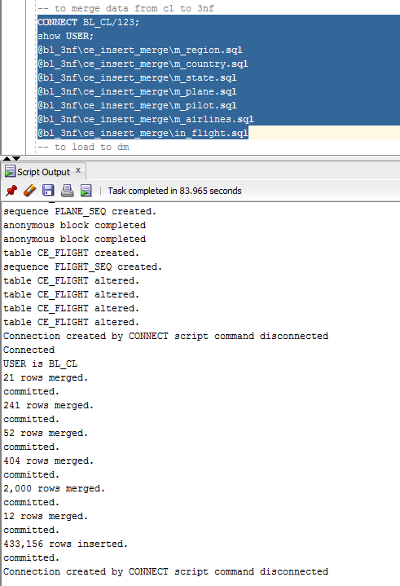

To load data to dimensions and fact table:

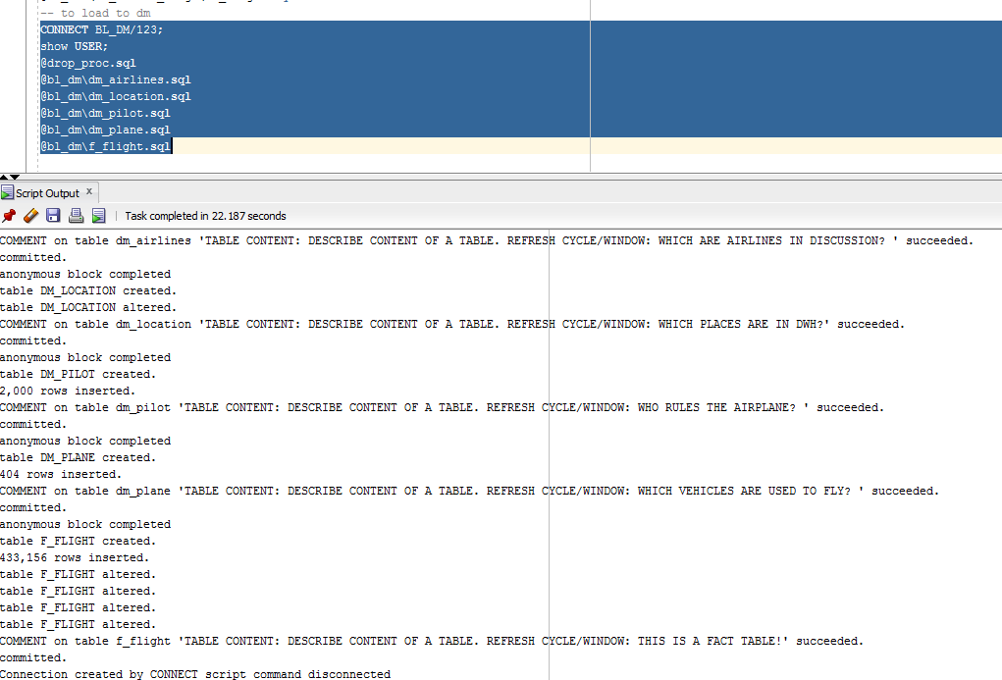

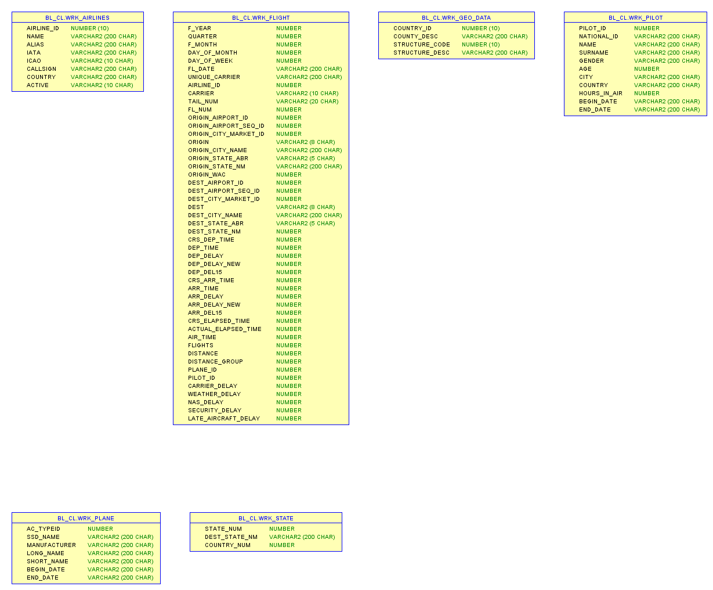

Figure Sources tables

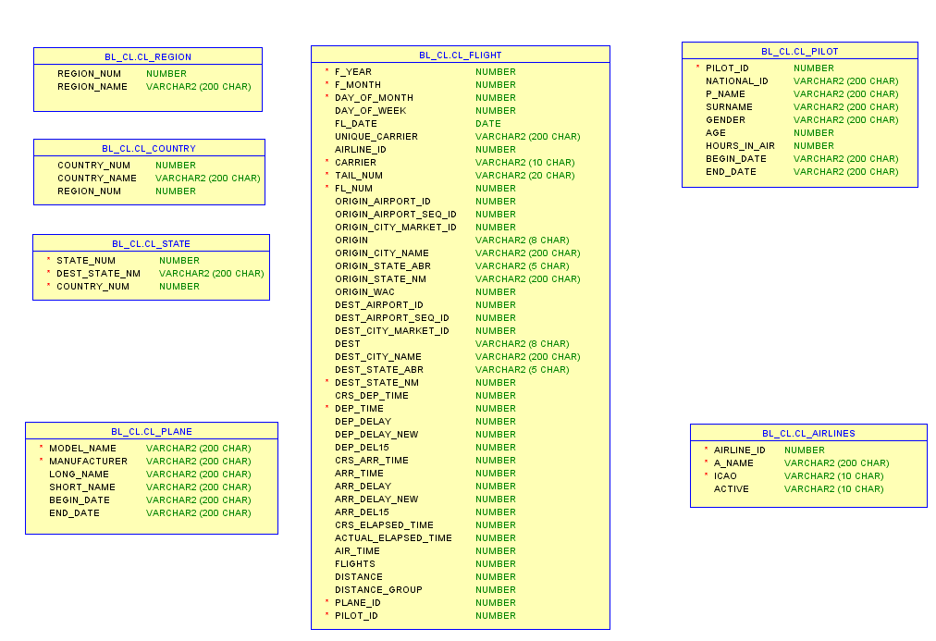

Figure Cleansing tables

# Fact Table Partitioning Strategy

This fact table will be partitioned by airlines. In the future, when data will be stored in the time period of different months and years it’s better to partition by months.

# Strategy of Parallel Load

It’s better to load all dimensional in parallel with fact table.

# Report Layouts

# Examples are stored down below.

# 

Figure Report example 1

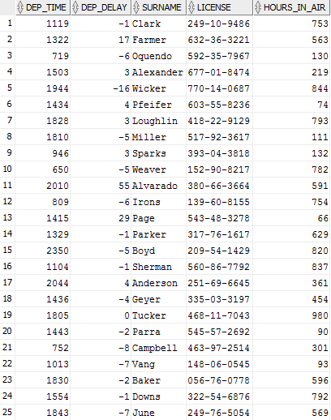

Figure Report example 2

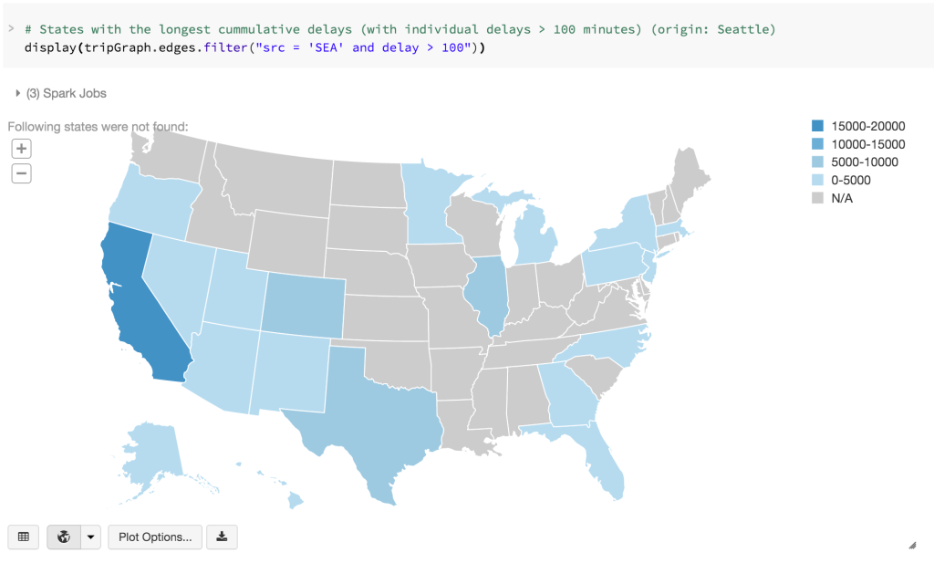

Figure Report example 3

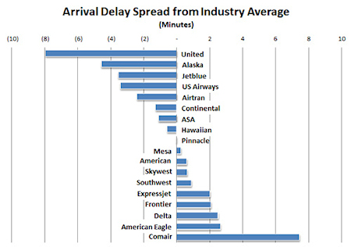

Figure Report example 4

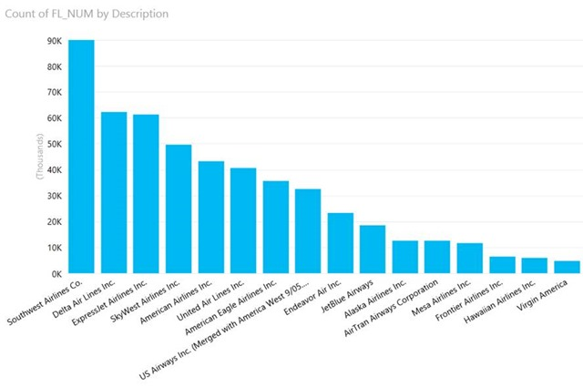

Figure Report example 5